**ABSTRACT**

The website of Clean and Green Foundation is to motivate people, it acts as a foundation and is striving to make Jalna City. green and clean. We work to make people aware of cleanliness, we work in such a place where the municipality does not work. Sometimes we work with municipality, our aim is to make Jalna city clean and green. and we will always try for this.

**1.INTRODUCTION**

As technology advance internet is becoming ever popular. Website has become as essential part. Often website os an institution is used as major requirements to rate it.

Thus having a website is essential for any major organization.

The website has been developed for CG Foundation in an effort to make it as attractive and dynamic as possible compare to the existing site CSS ,html as been added to our project.

In that website we developed webpage using css style for more attractive. First of all we have take basic webpage of html and after added some contains like navigation bar, menu bar, sub-menu and also using img tag display images. it also be added some images of Environmental.

**Resource**

1. **VS Code**
2. **Live server**
3. **Chrome**
4. **Notepad**
5. **Notepad + +**

**Language**

1. **Html 5**

Html stands for hyper text markup language. It is used to design web pages using a markup language. Html is an abbreviation of hypertext and markup language. Hypertext defines the link between the web pages. The markup language is used to define the text document within the tag which defines the structure of web pages. Html 5 is the fifth and current version of html.

1. **CSS**

Cascading style sheets (css) is a stylesheet language used to describe the presentation of a document written in html or xml (including xml dialects such as svg, MATHML or XHTML). Css describes how elements should be rendered on screen, on paper, in speech, or on other media.

**4. Home page code**

<html>

<head>

<meta name="viewport" content="width=device-width, initial-scale-1.0">

<title>CG F - project</title>

<link rel="stylesheet" href="CG style.css">

<link rel="stylesheet" href="https://fonts.google.com/css2?family=Robot:wght@400;700&display=swap">

</head>

<body>

<div class="container">

<div class="navbar">

<img src="logo.png" class="logo">

<nav>

<ul>

<li><a href="">Home</a></li>

<li><a href="file:///E:/New%20project%20CG/photos.html">Photos</a></li>

<li><a href="file:///E:/New%20project%20CG/about%20CG.html">About</a></li>

<li><a href="file:///E:/New%20project%20CG/Contact%20us.html">Contact us</a></li>

</ul>

</nav>

<img src="menu.png" class="menu-icon">

<button1>

<a href="file:///E:/New%20project%20CG/login.html#" type="btn" class="Login">Log in</a>

</button1>

</div>

<div class="row">

<div class="col">

<h1>Clean and Green Foundation</h1>

<p>The Clean and Green campaign aims to protect and care

for the environment by engaging the community in

leading an environmentally conscious lifestyle.</p>

<button href="file:///E:/New%20project%20CG/about%20CG.html" type="button" class="button">Explore</button>

</div>

<div class="col">

<div class="card card1" href="file:///E:/New%20project%20CG/photos.html">

<h5>Jalna</h5>

<p>It is currently administered by the National

Environment Agency.</p>

</div>

<div class="card card2" href="file:///E:/New%20project%20CG/photos.html">

<h5>Aurangabad</h5>

<p>It is currently administered by the National

Environment Agency.</p>

</div>

<div class="card card3" href="file:///E:/New%20project%20CG/photos.html">

<h5>Pune</h5>

<p>It is currently administered by the National

Environment Agency.</p>

</div>

<div class="card card4" href="file:///E:/New%20project%20CG/photos.html">

<h5>Mumbai</h5>

<p>It is currently administered by the National

Environment Agency.</p>

</div>

</div>

</div>

</div>

</body>

</html>

///css code

*{

margin: 0;

padding: 0;

font-family: 'Roboto', sans-serif;

}

.container{

width: 100%;

height: 100vh;

background-image: linear-gradient(rgba(0, 0, 0, 0.7),rgba(0,0,0,0.7)),url(background-img.jpg);

background-position: 100%;

background-size: cover;

padding-left: 8%;

padding-right: 8%;

box-sizing: border-box;

}

.navbar{

height: 12%;

display: flex;

align-items: center;

}

.logo{

width: 120px;

cursor: pointer;

}

.menu-icon{

width: 30px;

cursor: pointer;

margin-left: 40px;

display:hidden;

}

.login{

color: black;

font-size: 16px;

text-decoration: none;

background: white;

width: 50px;

height: 10px;

padding: 6px 12px;

border: 0px;

border-radius: 20px;

cursor: pointer;

}

.login:hover{

background: aqua;

cursor: pointer;

color: #000;

font-weight: 500;

}

nav{

flex: 1;

text-align: right;

}

nav ul li{

list-style: none;

display: inline-block;

margin-left: 60px;

}

nav ul li a{

text-decoration: none;

color: #fff;

font-size: 16px;

}

nav ul li a:hover{

color: aqua;

cursor: pointer;

}

.row{

display: flex;

height: 88%;

align-items: center;

}

.col{

flex-basis: 50%;

}

h1{

color: #fff;

font-size: 90px;

}

h1:hover{

color:aqua;

cursor: pointer;

}

p{

color: #fff;

font-size: 11px;

line-height: 15px;

}

p:hover{

color: aqua;

cursor: pointer;

}

button{

width: 180px;

color: #000;

font-size: 12px;

padding: 12px 0;

background: #fff;

border: 0;

border-radius: 20px;

outline: none;

margin-top: 30px;

}

button:hover{

background-color: aqua;

cursor: pointer;

}

.card{

width: 200px;

height: 230px;

display: inline-block;

border-radius: 10px;

padding: 15px 25px;

box-sizing: border-box;

cursor: pointer;

margin: 10px 15px;

background-image: url(clean.jpg);

background-position: center;

background-size: cover;

transition: transform 0.5s;

opacity: 50%;

}

.card1{

background-image: url(img\ \(1\).jpg);

}

.card2{

background-image: url(img\ \(2\).jpg);

}

.card3{

background-image: url(img\ \(3\).jpg);

}

.card4{

background-image: url(img\ \(4\).jpg);

}

.card:hover{

transform: translateY(-30px);

opacity: 100%;

}

@media (max-width: 1200px) {

.card{

justify-items: auto;

}

.container{

width: 100%;

}

}

h5{

color: #fff;

text-shadow: (0 0 5px #999);

}

.card p{

text-shadow: 0 0 15px rgb(218, 25, 25);

font-size: 8px;

}

**Screenshot**

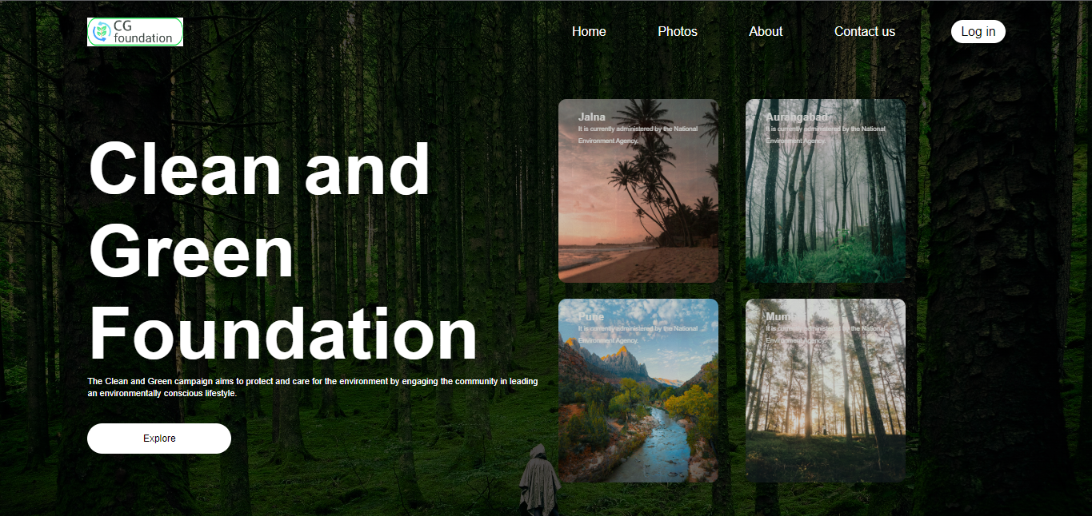

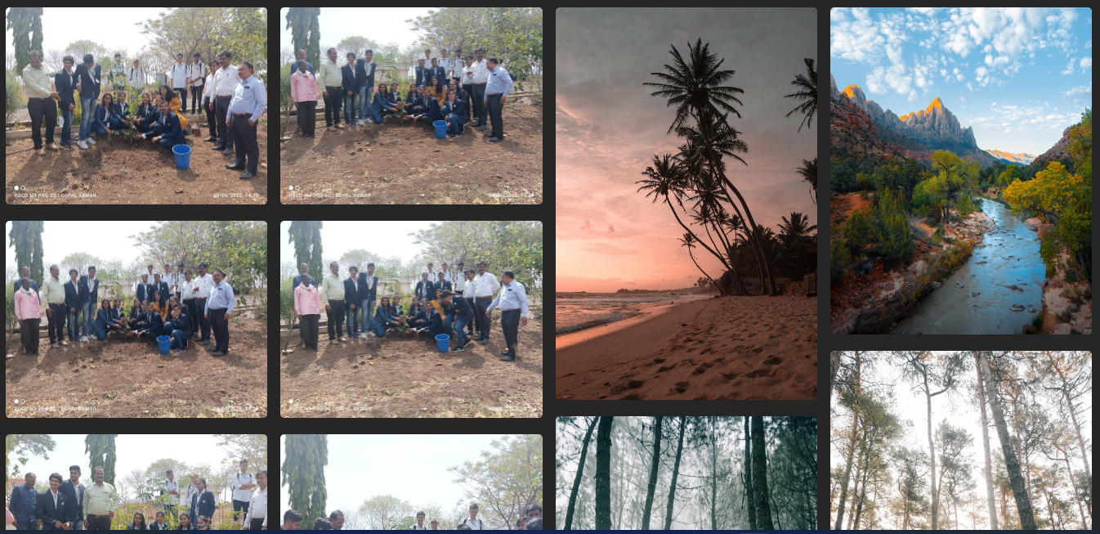

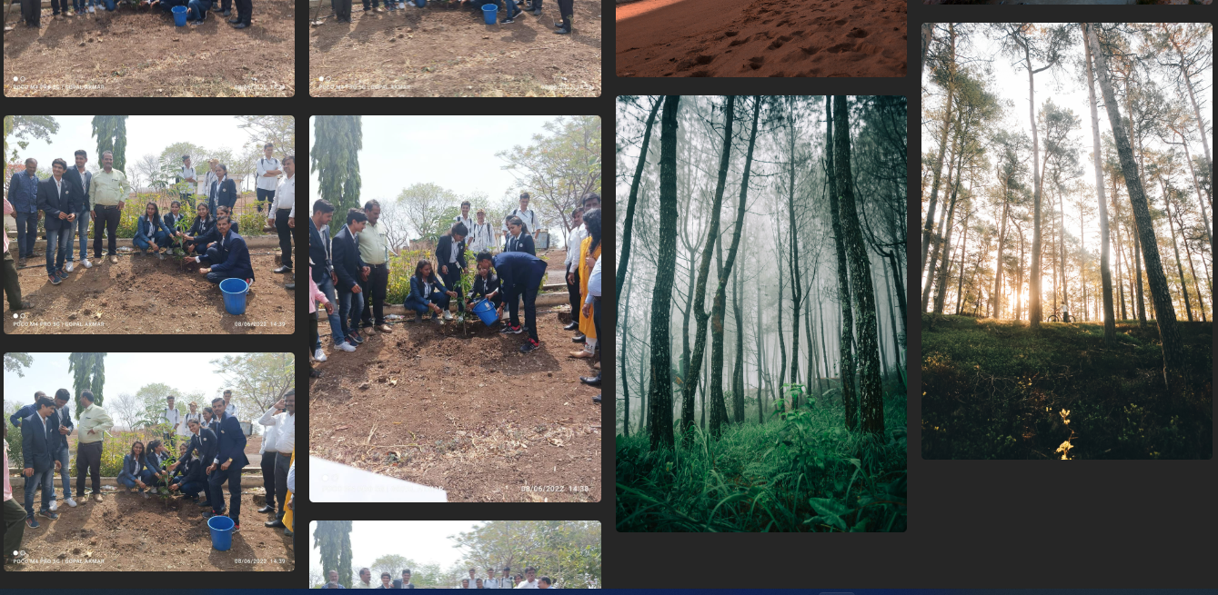

**About us page**

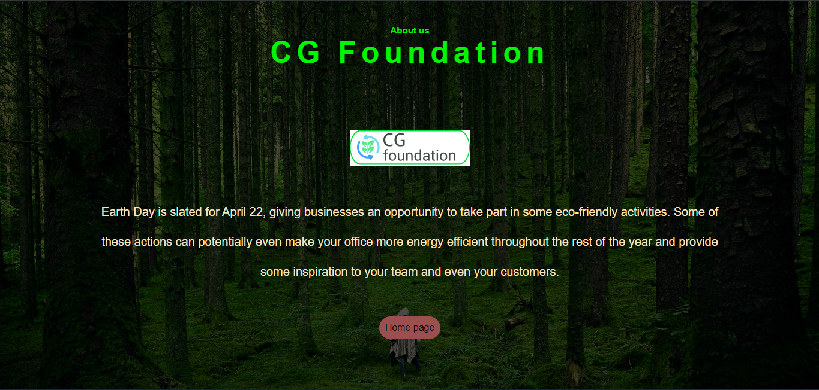

**Contact us page**

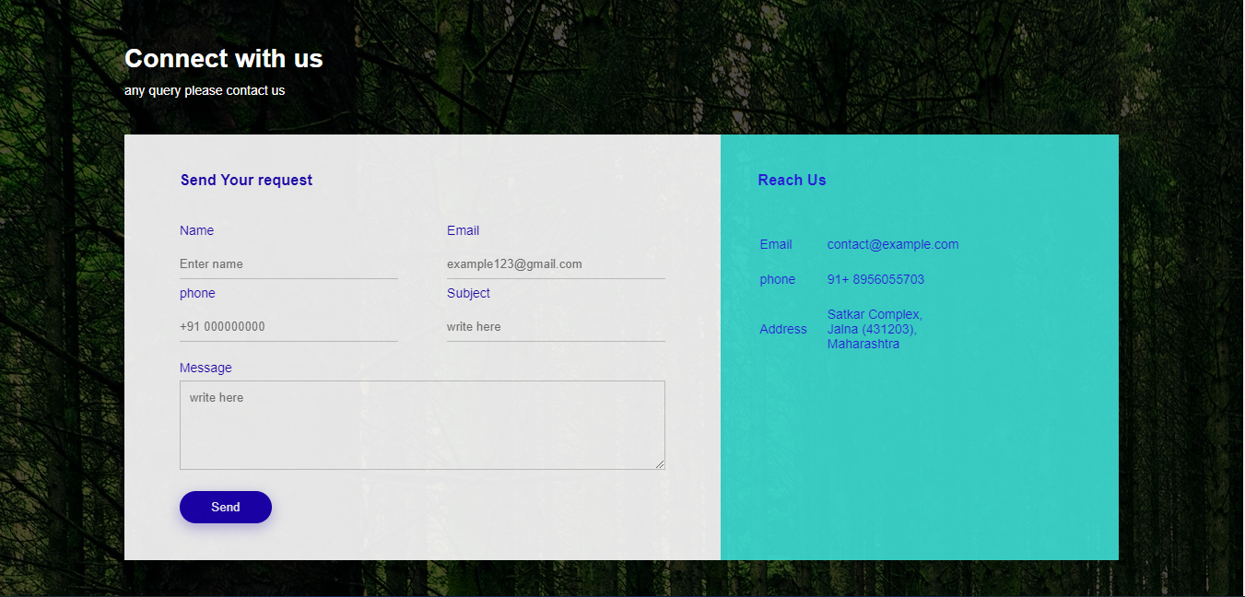

**Login page code:**

**#html**

<!DOCTYPE html>

<!-- html coding for login form-->

<html lang="en" dir="ltr">

<head>

<meta charset="utf-8">

<title>Login Form | CG Foundation</title>

<link rel="stylesheet" href="loginstyle.css">

</head>

<body>

<div class="center">

<h1>Login</h1>

<form action="login.php" method="post">

<div class="txt_field">

<input type="text" name="username" required>

<span></span>

<label>Username</label>

</div>

<div class="txt_field">

<input type="password" name="password" required>

<span></span>

<label>Password</label>

</div>

<div class="pass">Forgot Password?</div>

<input type="submit" value="Login">

<div class="signup_link">

Not a member? <a href="#">Signup</a>

</div>

</form>

</div>

</body>

</html>

**///login css code**

<!DOCTYPE html>

<!-- html coding for login form-->

<html lang="en" dir="ltr">

<head>

<meta charset="utf-8">

<title>Login Form | CG Foundation</title>

<link rel="stylesheet" href="loginstyle.css">

</head>

<body>

<div class="center">

<h1>Login</h1>

<form action="login.php" method="post">

<div class="txt_field">

<input type="text" name="username" required>

<span></span>

<label>Username</label>

</div>

<div class="txt_field">

<input type="password" name="password" required>

<span></span>

<label>Password</label>

</div>

<div class="pass">Forgot Password?</div>

<input type="submit" value="Login">

<div class="signup_link">

Not a member? <a href="#">Signup</a>

</div>

</form>

</div>

</body>

</html>

**Screenshot**

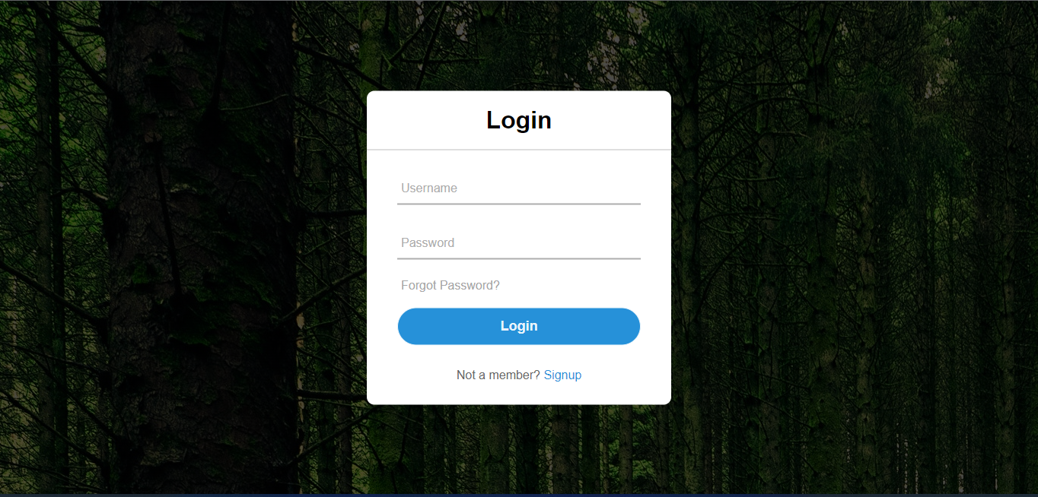

**CONCLUSION**

The main goal of our website is that every student known the important of Environment and cleanliness very necessary for student that they know about Environmental , pollution , cleanliness.

**REFFERENCE**

1) https://www.w3.org

2) <https://www.geeksforgeeks.org>

3) https://www.slideshare.net/

4) <https://www.w3schools.com/>

5) https://www.tutorialspoint.com/